Content 10

**I/O In files**

The random access memory is volatile and all its contents are lost once a program terminates.

In order to persist the data forever, we use files.

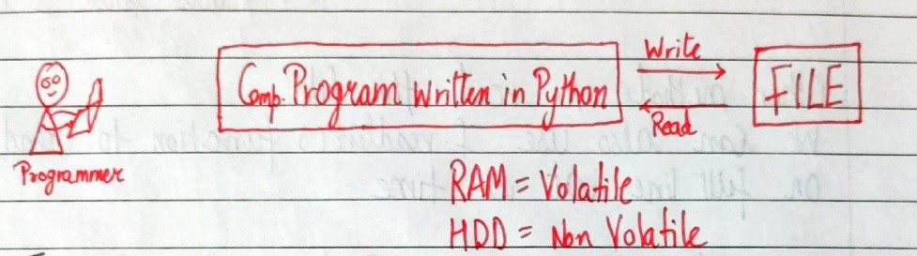

**Types of Files**

There are 2 types of files:

1. Text files (.txt, .c, etc)
2. Binary files (.jpg, .dat, etc)

Python has a lot of functions for reading, updating, and deleting files.

**Opening a file**

Python has an open() function for opening files. It takes 2 parameters: filename and mode.

open(“this.txt”, “r”)

Here, “this” is the file name and “r” is the mode of opening (read mode)

**Reading a file in Python**

f = open(“this.txt”, “r”)     #Opens the file in r mode

text = f.read()          #Read its content

print(text)     #Print its contents

f.close()         #Close the fie

We can also specify the number of characters in read () function:

f.read(2)       #Reads first 2 characters

**Other methods to read the file**

We can also use f.readline() function to read on full line at a time.

f.readline()               #Reads one line from the file

**Modes of opening a file**

r – open for reading

w – open for writing

a – open for appending

+ -> open for updating

‘rb’ will open for read in binary mode

‘rt’ will open for read in text mode

**Writing Files in Python**

In order to write to a file, we first open it in write or append mode after which, we use the python’s f.write() method to write to the file!

f = open(“this.txt”, “w”)

f.write(“This is nice”)        #Can be called multiple times

f.close()

**With statement**

The best way to open and close the file automatically is the “with” statement.

with open(“this.txt”) as f:

            f.read()

#There is no need to write f.close() as it is done automatically

**Code for describing modes and some operation using the modes:**

# reading the file

print("Reading the content of the file........")

f = open('Cnt10.txt', 'r')

# a= f.read() #for reeading th  whole content present in the file

a = f.readline()  # for reeading lines present in the file

print(a)

f.close()

# Using the write mode

print("/n/nWriting in the file by write Mode")

f = open('Cnt10.txt', 'w')  # it erase the cotent

f.write("Computer Contains various types of passive elements.")

f.close()

# using the appending mode

print("\n\nPerforming appending operation on the file")

f = open('Cnt10.txt', 'a')

f.write(".\nI am appending...")  # it will add the content at end

f.close()

# with statement for modes which automatically closes the file

with open('Cnt10.txt', 'r') as f:

    print("\n\nShowing the content present in the file with the help of r mode")

    a = f.read()

print(a)

with open('Cnt10.txt', 'a') as f:

    print("Addding the content in the file by the use of a mode")

    f.write("\nI am the one.")

with open('Cnt10.txt', 'r') as f:

    print("\n\nThe new content added in he file is")

    a = f.read()

    print(a)

**Program for searching the word in a file:**

**Cnt10b.txt File:**

My name is Alisha

Code:

with open('Cnt10b.txt','r') as f2:

    f=f2.read()

if "Alisha" in f:

    n="Alisha"

    print("We got the word: ",n)

else:

    print("Word is not present.")

**Ouput:**

We got the word: Alisha

**Program for replacing the highest score in file:**

**Cnt10b.txt Before:**

11

**Code:**

# for storig the high score of game

def game():

    return 112

new_score=game()

with open("Cnt10b.txt") as f:

    highscore= int(f.read())

if highscore<new_score:

    with open("Cnt10b.txt","w") as f:

        f.write(str(new_score))

else:

    print("Your score is low...")

**Cnt10b.txt After:**

112